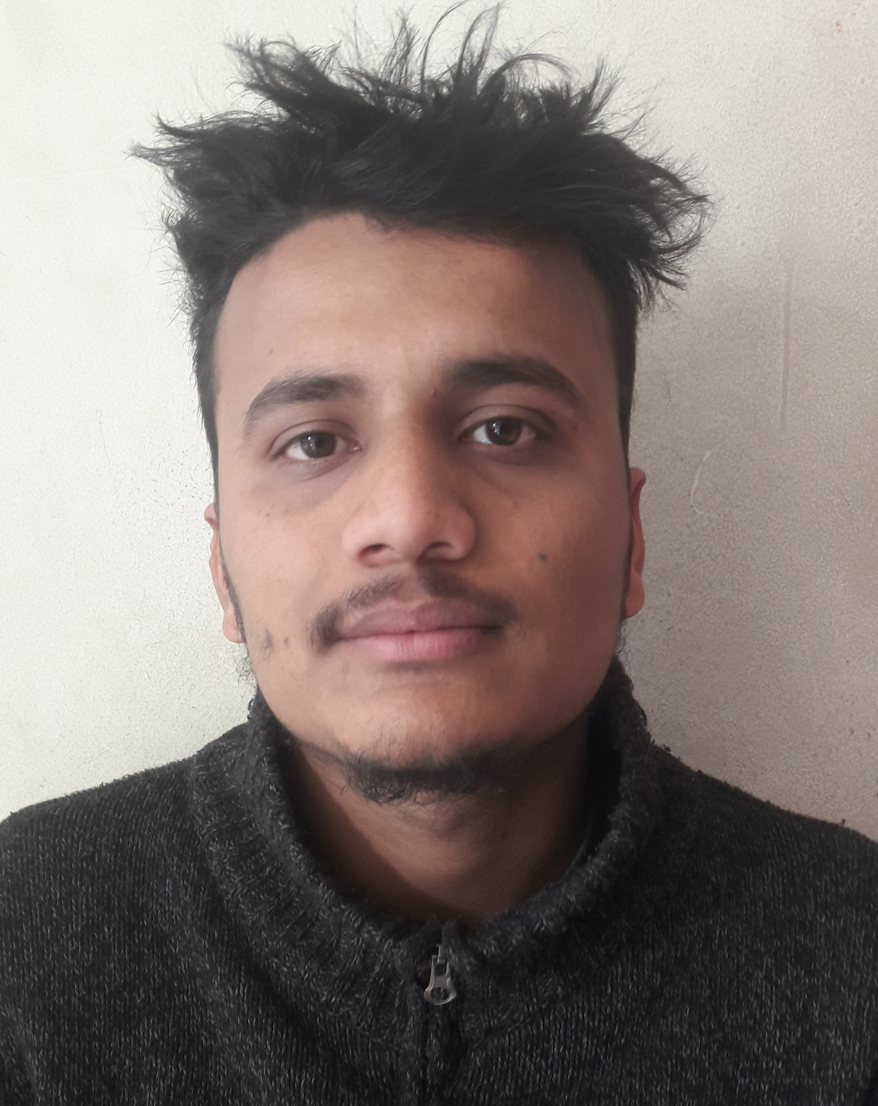

**Mr. PRABESH GOULI**

***Maharajgunj-03, Kathmandu, Nepal***

***Mobil No: +***9779823826272  
**Email Address:** [prabesh7@gmail.com](mailto:prabesh7@gmail.com),

Prabesh.gouli@Studentpartner.com

prabeshgouli.msp2018@mspnepal.com

***personal objective***

To be able to join any reputable institution where I can impart my skills, abilities and knowledge obtained from any previous work experiences and educational back ground

To be able to use gained skills with the contradiction of mind and heart towards the institution's best.

***key skills***

* Hard Working , Punctual & Optimistic
* Good Learning & Listening Abilities
* Learn quickly, and able to work under pressure.
* Results-oriented, self-starter with experience
* Adobe Photoshop
* Programming language: c, c++, PHP,HTML,Java Script,Aurdino Ide ,bootstrap, sweet alert,HTML5,Visual Studio 2017(*Basic*),PYTHON(*Learning*)
* Hardware and networking
* Web page designing

***Personal Details***

*Father’s name :* Bishnu pd. Gouli

*Date of Birth :* 2054-07-04 B.S/1997-10-20A.D

*Nationality : Nepalese*

*Gender : Male*

*Marital Status : Unmarried*

*Language Known : English, Hindi and Nepali*

*Mobile Phone No. : 9823826272*

***EDUCATIONAL QUALIFICATION***

|  |  |  |  |  |
| --- | --- | --- | --- | --- |
| **Level** | **Institution** | **Division** | **Percentage** | **Passed Year** |
| S.L.C. | Herald Int’l H.S. School, Kathmandu, Nepal | 1st | 74% | 2012A.D. |
| +2 | National school of science(NIST), Kathmandu, Nepal | 1st | 60.01% | 2014 A.D. |
| Bachelor(Bachelor engineering in electronic and communication) | Advance college of engineering and management-affilated to TU , kupondel-Lalitpur | Running(6Th semester) |  |  |

***EXPERIENCE***

* *Worked as project group leader to built project like smart farming, garbage monitoring system, fire and gas indication system, smart home,Hellow switch etc*
* *Tutor at Quick solution Point on MTA( Microsoft Technical Assistance on Networking and its Fundamental)*
* *Developed different website for clients*
* *Worked as project leader on Unlimited-APPATHON 2018*
* *Worked as Laptop and Desktop technician*

***declaration***

* I certify that all the details provided above are all correct according to my knowledge and belief.

**Prabesh Gouli**